Modern Slavery and Human Trafficking Statement
Roper Rhodes
2024

Contents

1. Introduction 2
2. Organisational Structure & Activities 2
2.1. Our Supply Chain 3
3. Our Due Diligence 4
3.1. Our Governance, Policies & Procedures 5
3.2. Annual Risk Assessments 6
3.2.1. Results annual risk assessment 6
3.2.2. Mitigation and grievance mechanism 7
3.3. Training 7
3.4. Next steps 7
Approval 7

Introduction
This statement is made pursuant to section 54(1) of the U.K. Modern Slavery Act 2015 (the “MSA”) and constitutes the slavery and human trafficking statement of Roper Rhodes ltd (“Roper Rhodes”, “we”, “our”) for the year ended 31 December 2023.

At Roper Rhodes, we are committed to improving our practices to combat slavery and human trafficking and are committed to our due diligence in order to minimise and mitigate any riskof slavery and human trafficking taking place in our supply chains or in any parts of our business.

Modern slavery and human trafficking are a violation of fundamental human rights:
- Modern Slavery is a term which encompasses slavery, servitude and forced or compulsory labour. It includes Child Labour which, as defined by the International Labour Organisation (“ILO”), is work that deprives children of their childhood, their potential, and their dignity, and that is harmful to their physical and mental development.
- Human trafficking is defined as arranging or facilitating the travel of another person with a view to that person being exploited.

The purpose of this statement is to set out our Due Diligence and any further steps that Roper Rhodes has taken during the year January 2023 to December 2023 to ensure that modern slavery and human trafficking is not occurring in our organisation or in our supply chains. It also highlights our next steps for 2024.

This policy statement is reviewed annually, updated as appropriate, and published on our website.

Organisational Structure & Activities
Roper Rhodes was founded in 1979 and has grown from a small family business to being one the of UK’s leading independent suppliers of bathroom furniture and products.
Roper Rhodes Ltd has been acquired by Svedbergs Group as of 1 December 2021. Svedberg Group operate especially in the Bathroom sector across the Nordic region, and they are specialists in the design and manufacture of bathroom products and most notably bathroom furniture.

The Roper Rhodes Group incorporates all of the brands and ranges we sell:
- Roper Rhodes
- R2
- Tavistock

We have approximately 234 employees over two sites:
- Head Office in Bath
- National Distribution Centre in Portbury, Bristol

Within each site we have the following departments:
- Head Office:
  - Directors
  - Customer Service
  - New Product Development
  - Finance
  - IT
  - Marketing Communications
  - Supply Chain
  - Sustainability
- National Distribution Centre:
  - Warehouse
  - Quality Control
  - HR
  - Product Displays

We also have a field sales force who cover England, Ireland, Scotland and Wales. We are a Business to Business organisation selling our products to Bathroom showrooms across the UK and Ireland. Our products are designed in the UK and manufactured around the world (please see Supply Chain information below)

Our Management Systems are modelled upon ISO standards aimed at delivering continuous improvements over time. We set Policy Objectives over the issues to be managed; we set annual measurable goals (targets), and determine the action required to meet those goals. We check our progress to ensure our policy objectives and set goals are being achieved.

Our Supply Chain
We have Supply Chain team of 6 employees who work with our suppliers to ensure efficient delivery of our products by:
- Planning delivery timetables
- Ensuring stores have enough stock
- Making sure suppliers have enough stock to meet demand
- Overseeing the ordering and packaging process
- Monitoring stock levels
- Tracking products through depots to make sure they arrive at their destination
- Overseeing arrival of shipments

We currently deal with suppliers from the following countries:
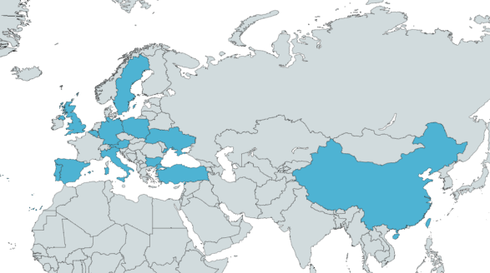
Table 1 . Roper Rhodes supply chain map

Roper Rhodes Limited and its group companies are absolutely committed to preventing slavery and
human trafficking in its corporate activities, and to ensuring that its supply chains, including
those of its sub-contractors and partners, are free from slavery and human trafficking.
The Company acknowledges responsibility to the Modern Slavery Act 2015 and will ensure
transparency within the organisation and with suppliers of goods and services to the
organisation.

Our Due Diligence
As part of Roper Rhodes’s due diligence processes into slavery and human trafficking, the suppliers’ approval process incorporates a review of the controls undertaken by the supplier. Imported
goods from sources from outside the UK and EU are potentially more at risk for slavery/human
trafficking issues. The level of management control required for these sources is continually
monitored.

We have effective business practices in place to ensure effective reporting and action to address modern slavery. These include:
- Group factory evaluation reports (audits run by Roper Rhodes, and SMETA audits)
- Proof of minimum working age requirements.
- Risk management processes
- Grievance policy
- Company culture of respect for human rights and zero tolerance of modern slavery throughout the organisation
To achieve our goals we have been a Sedex (Supplier Ethical Data Exchange) member since 2012, and we annually complete the SAQ (Self-Assessment Questionnaire). We also use Sedex to collect supply chain information, to run risk assessments, and to require SMETA (Sedex Members Ethical Trade Audit) audits for our suppliers, as relevant.

Our Supply Chain requirements
We require all our suppliers to sign our Supplier Code of Conduct. We also require our Product suppliers to:
- Register on the Sedex platform
- Complete the Sedex SAQ
- Run a SMETA audit if we deem necessary e.g. the supplier operates in a high-risk country, as identified after annual risk assessment, or their SAQ and audit has flagged critical non-compliances.

Our Governance, Policies & Procedures
  - Governance
The Company Directors and senior management shall take responsibility for implementing this
policy statement and its objectives and shall provide adequate resources (training, etc) and
investment to ensure that slavery and human trafficking is not taking place within the
organisation and within its supply chains.

Furthermore, a ‘Responsible Sourcing’ working group has also been created to:
- Implement our Supplier Risk Management Policy
- Update the Roper Rhodes Sedex SAQ annually
- Run annual risk assessments using Sedex Radar
- Engage our suppliers to align with our requirements
- Monitor, Track and Report on suppliers’ compliance and performance

The group is also responsible for the monthly reporting to the Operations and Product Directors. Any supplier non-compliant with our standards, is flagged to the Directors and further steps are taken to ensure that any risk is mitigated.

Table 2. Modern Slavery Supply Chain Governance

  - Policies & Procedures
This Policy Statement takes into account, and supports, the policies, procedures and requirements documented in our Management System. The implementation and operation of this management system underlines our commitment to this policy.

The following policies exist within the business and link to the company stance on Modern Slavery & Human Trafficking:
- Modern Slavery Policy
- Recruitment Policy
- Disciplinary Policy
- Grievance Policy
- Anti-Corruption & Bribery Policy
- Social Media Policy
- Whistleblowing Policy
- Supplier Code of Conduct
- Employee Code of Conduct
- Supplier Risk Management Policy

Annual Risk Assessments
The aim of running annual risk assessments is to identify the various risks to human rights and the environment, that can occur in industries and regions around the world.

At Roper Rhodes we are absolutely committed to preventing human rights violations, and to ensuring that our supply chains are free from any human rights infringements.

We use the Sedex Radar tool to prioritise annual risk assessments, and improvement efforts depending on the most common or severe issues – an important component of effective supply chain due diligence. We run a risk assessment report annually to summarise the results of the analysis, we report on any significant findings and we set further actions.

Results annual risk assessment
Country/Region and Sector risk assessment
The Country/Region and Sector risk assessment run in January 2024 for calendar year 2023, confirmed which suppliers are based in high-risk countries (China, Turkey). All other suppliers we source from are based in low to medium risk countries.

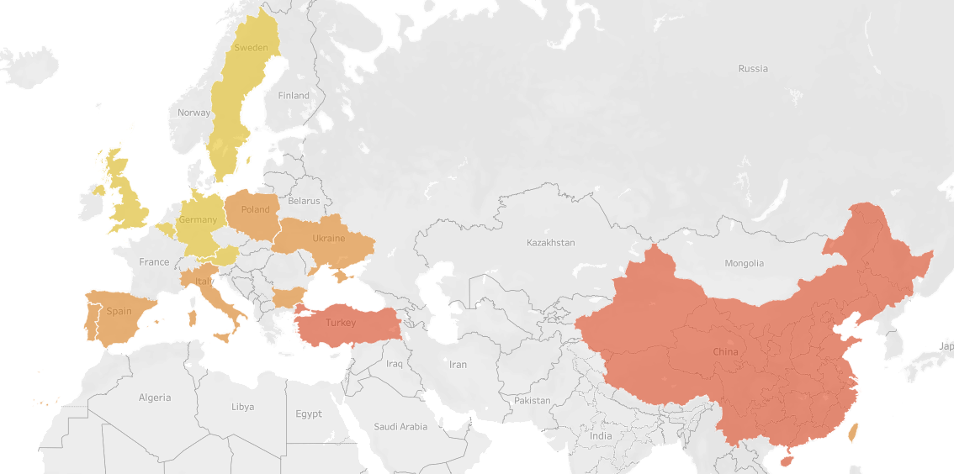
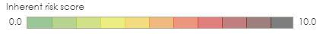
Table 3. The Country/Region and Sector risk assessment map

Site-specific risk assessment
Additionally, we run site specific risk assessment, to identify the risks related to each supplier, based on their answers to the Sedex SAQs and the results from the SMETA audits.

When critical, major and minor NCs have been reported, they relate to:
- Working hours
- Wages
- H&S
- Environment
When NCs are identified, the supplier is requested to:
- Repeat a SMETA audit, as relevant depending on the type of NCs
- Close any NCs in a timely manner.
No risks have been identified in our own organisation assessment or evaluation conducted during the 2023 calendar year and no business critical risks have been identified across our supply chain.

Mitigation and grievance mechanism
We mitigate risks in our organisation and supply chain:
- By continuing self-assessment of our organisation using Sedex.
- By training our employees on Modern Slavery & Human Trafficking, and by communicating the relevant policies.
- By building a strong onboarding process for our suppliers which prioritises compliance with our legal and sustainability requirements, and our Supplier Code of Conduct; specific clauses are being added to the terms of conditions of our contract.
- By analysing the SAQs and SMETA audits reports, and using the tools provided by Sedex to track and monitor compliance and risk status.

Grievance procedure will apply to all employees as per our Grievance Policy, and cover all cases where the employee wishes to raise a particular grievance in connection with their employment. In our whistleblowing service, internal and external stakeholders can submit a report on suspicion of serious misconduct or violations to human rights.

Training
This statement and accompanying policies are made available to all employees when they join the company. Any changes are communicated across the company and training provided if needed.
We are also launching e-learning training sessions on Modern Slavery and Human Trafficking for all our employees. More in-depth sessions will also run for specific employees and managers based on their job role.

Next steps
We will:
- Continue towards achieving our targets by 2030, keep assessing our supply chain to reduce and mitigate any risks in relation to Human Rights violations, and make sure our suppliers align with our standards.
- Continue to be vigilant when assessing areas of potential risk within our supply chain
- Monitor suppliers’ NCs and work towards ensuring that all NCs are closed in a timely manner.
- Implement our Supplier Risk Management Policy.
- Act promptly where a compliance breach has been identified or flagged.
- Continue to provide training and awareness both internally and externally .
- Measure and report progress on the actions above within our 2023 to 2024 statement.

Approval
This statement has been approved by the company’s board of directors.

‘Risk’ in human rights and environmental terms translates into identifying adverse human rights or environmental impacts and the probability that these impacts might occur.
Svedbergs Group consist of: Svedbergs i Dalstorp AB, Macro Design AB, Cassoe A/S, Roper Rhodes ltd and Thebalux.
We source from China, Germany, Austria, UK, Italy, Belgium, Turkey, Bulgaria, Spain, Taiwan, Poland, Ukraine, Sweden, and Portugal.
Sedex Members’ Ethical Trade Audit.
It assesses Labour Standards, Health & Safety, Environment and Business Ethics performance.
Sedex risk assessment tool.
Our Supplier Risk Management Policy in particular covers how we classify, assess, and identify risks in our supply chain and how we deal with cases of non-compliance to our requirements and standards.
Running annual risk assessment helps us to understand what the most likely issues in our organisation and supply chains are and will be, even at the earliest stages of risk assessment. This helps us to take action to protect people, the planet, and our own business from negative impacts.
This assessment considers the geographical location and industry of our Tier 1 suppliers.
20% of our strategic suppliers to be audited each year; 100% of our critical suppliers to be audited by 2030.

